SERVER.JS

*const* express=require('express');

*const* app=express();

*var* path=require('path');

app.use(express.static(path.join(__dirname,'public')));

app.use(express.urlencoded({extended:true}));

app.use(express.json());

app.get("/",*function*(*req*, *res*){

    res.sendFile("index.html");

});

*var* routes=require("./router");

routes(app);

app.listen(7878,()*=>*{ console.log("server started at port no 7878")

})

ROUTER.JS

*const* flowerconntroler=require('./controller/flowerconntroler');

*const* customerconntroler=require('./controller/customerconntroler');

*const* ordersconntroler=require('./controller/ordersconntroler');

*const* ordersitemconntroler=require('./controller/ordersitemconntroler');

module.exports=*function*(*app*){

    app.route("/api/flowers")

    .get(flowerconntroler.getall)

     .post(flowerconntroler.insert)

     .put(flowerconntroler.update)  ;

     app.route("/api/flowers/:id")

.get(flowerconntroler.getByid)

.delete(flowerconntroler.remove);

//===================================================================================

app.route("/api/customers/:id")

 .get(customerconntroler.getByid)

  .delete(customerconntroler.remove);

  app.route("/api/customers")

  .get(customerconntroler.getall)

   .post(customerconntroler.insert)

   .put(customerconntroler.update)  ;

//===================================================================================

  app.route("/api/orders")

  .get(ordersconntroler.getall)

   .post(ordersconntroler.insert)

   .put(ordersconntroler.update)  ;

   app.route("/api/orders/:id")

 .get(ordersconntroler.getByid)

  .delete(ordersconntroler.remove);

//===================================================================================

   app.route("/api/ordersitem")

   .get(ordersitemconntroler.getall)

    .post(ordersitemconntroler.insert)

    .put(ordersitemconntroler.update)  ;

   app.route("/api/ordersitem/:id")

 .get(ordersitemconntroler.getByid)

  .delete(ordersitemconntroler.remove);

}

CONTROLLERS

1.FLOWERCONNTROLER

*var* FLOWER=require("../modules/flowermodule");

exports.getall=*function*(*request*,*response*){

    FLOWER.getall(*function*(*err*,*data*){

        if(err){

            response.send("err")

        }

        else

        {

            response.send(data);

        }

    })

}

exports.insert=*function*(*request*,*response*){

*var* newflower=new FLOWER.flower(request.body);

      FLOWER.insert(newflower,*function*(*err*,*data*){

        if(err){

            response.send("err")

        }

        else

        {

            response.send(data);

        }

      })

};

exports.getByid=*function*(*request*,*response*){

*var* id=request.params.id;

    FLOWER.getby(id,*function*(*err*,*data*){

        if(err){

            response.send(err);

        }

        else{

            response.send(data);

        }

    })

};

exports.update=*function*(*request*,*response*){

*var* newflower=new FLOWER.flower(request.body);

*var* id=newflower.id;

    console.log(id);

    FLOWER.update(id,newflower,*function*(*err*,*data*){

        if(err){

            response.send(err);

        }

        else{

            response.send(data);

        }

    })

};

exports.remove=*function*(*request*,*response*){

*var* id=request.params.id;

    FLOWER.remove(id,*function*(*err*,*data*){

        if(err){

            response.send(err);

        }

        else{

            response.send(data);

        }

    })

};

2.CUSTOMER

*var* CUSTOMER=require("../modules/customermodule");

exports.getall=*function*(*request*,*response*){

    CUSTOMER.getall(*function*(*err*,*data*){

        if(err){

            response.send("err")

        }

        else

        {

            response.send(data);

        }

    })

}

exports.insert=*function*(*request*,*response*){

*var* newcustomer=new CUSTOMER.customer(request.body);

      CUSTOMER.insert(newcustomer,*function*(*err*,*data*){

        if(err){

            response.send("err")

        }

        else

        {

            response.send(data);

        }

      })

};

exports.getByid=*function*(*request*,*response*){

*var* id=request.params.id;

    CUSTOMER.getby(id,*function*(*err*,*data*){

        if(err){

            response.send(err);

        }

        else{

            response.send(data);

        }

    })

};

exports.update=*function*(*request*,*response*){

*var* newcustomer=new CUSTOMER.customer(request.body);

*var* id=newcustomer.id;

    console.log(id);

    CUSTOMER.update(id,newcustomer,*function*(*err*,*data*){

        if(err){

            response.send(err);

        }

        else{

            response.send(data);

        }

    })

};

exports.remove=*function*(*request*,*response*){

*var* id=request.params.id;

    CUSTOMER.remove(id,*function*(*err*,*data*){

        if(err){

            response.send(err);

        }

        else{

            response.send(data);

        }

    })

};

3.ORDERS

*var* ORDERS=require("../modules/ordersmodule");

exports.getall=*function*(*request*,*response*){

    ORDERS.getall(*function*(*err*,*data*){

        if(err){

            response.send("err")

        }

        else

        {

            response.send(data);

        }

    })

}

exports.insert=*function*(*request*,*response*){

*var* neworder=new ORDERS.order(request.body);

    ORDERS.insert(neworder,*function*(*err*,*data*){

        if(err){

            response.send("err")

        }

        else

        {

            response.send(data);

        }

      })

};

exports.getByid=*function*(*request*,*response*){

*var* id=request.params.id;

    ORDERS.getby(id,*function*(*err*,*data*){

        if(err){

            response.send(err);

        }

        else{

            response.send(data);

        }

    })

};

exports.update=*function*(*request*,*response*){

*var* neworder=new ORDERS.order(request.body);

*var* oid=neworder.oid;

    console.log(oid);

    ORDERS.update(oid,neworder,*function*(*err*,*data*){

        if(err){

            response.send(err);

        }

        else{

            response.send(data);

        }

    })

};

exports.remove=*function*(*request*,*response*){

*var* oid=request.params.id;

    ORDERS.remove(oid,*function*(*err*,*data*){

        if(err){

            response.send(err);

        }

        else{

            response.send(data);

        }

    })

};

4.ORDERSITEM

*var* ORDERSITEM=require("../modules/orderitemmodule");

exports.getall=*function*(*request*,*response*){

    ORDERSITEM.getall(*function*(*err*,*data*){

        if(err){

            response.send("err")

        }

        else

        {

            response.send(data);

        }

    })

}

exports.insert=*function*(*request*,*response*){

*var* neworderitem=new ORDERSITEM.ordersitem(request.body);

    ORDERSITEM.insert(neworderitem,*function*(*err*,*data*){

        if(err){

            response.send("err")

        }

        else

        {

            response.send(data);

        }

      })

};

exports.getByid=*function*(*request*,*response*){

*var* oiid=request.params.id;

    ORDERSITEM.getby(oiid,*function*(*err*,*data*){

        if(err){

            response.send(err);

        }

        else{

            response.send(data);

        }

    })

};

exports.update=*function*(*request*,*response*){

*var* neworderitem=new ORDERSITEM.ordersitem(request.body);

*var* id=neworderitem.id;

    console.log(id);

    ORDERSITEM.update(id,neworderitem,*function*(*err*,*data*){

        if(err){

            response.send(err);

        }

        else{

            response.send(data);

        }

    })

};

exports.remove=*function*(*request*,*response*){

*var* id=request.params.id;

    ORDERSITEM.remove(id,*function*(*err*,*data*){

        if(err){

            response.send(err);

        }

        else{

            response.send(data);

        }

    })

};

MODULES

1.FLOWERSMODULE

*var* database=require('../mysqlconnection');

exports.flower=*function*(*flower*){

    this.id=flower.id;

    this.fname=flower.fname;

    this.description=flower.descriptio;

    this.quantity=flower.quantity;

    this.unitprice=flower.unitprice;

    this.likes=flower.likes;

}

exports.getall=*function*(*result*){

database.query("select * from flowers",*function*(*err*,*data*){

    if(err){

        console.log(err,null)

        result(null,err)

    }

    else{

        console.log(data,null)

        result(null,data)

    }

})

}

exports.insert=*function*(*newflower*,*result*){

    database.query("insert into flowers set ?",newflower,*function*(*err*,*data*){

        if(err){

            console.log(err,null)

            result(null,err)

        }

        else{

            console.log(data,null)

            result(null,data)

        }

    })

    };

    exports.getby=*function*(*id*,*result*){

        database.query("select * from flowers where id= ? ",id,*function*(*err*,*data*){

            if(err){

                console.log(err,null)

                result(null,err)

            }

            else{

                console.log(data,null)

                result(null,data)

            }

        })

    };

    exports.update=*function*(*id*,*newflower*,*result*){

        database.query("UPDATE flowers SET fname = ? WHERE Id = ?", [newflower.fname , id],

*function* (*err*, *res*) {

            if(err) {

                  console.log("error: ", err);

                  result(null, err);

              }

            else{

              result(null, res);

              }

          });

};

exports.remove=*function*(*id*,*result*){

    database.query("delete from flowers WHERE Id = ? ", id,

*function* (*err*, *res*) {

        if(err) {

              console.log("error: ", err);

              result(null, err);

          }

        else{

          result(null, res);

          }

      });

};

2.CUSTOMERMODULE

*var* database=require('../mysqlconnection');

exports.customer=*function*(*customer*){

    this.id=customer.id;

    this.firstname=customer.firstname;

    this.lastname=customer.lastname;

    this.email=customer.email;

    this.contactno=customer.contactno;

}

exports.getall=*function*(*result*){

database.query("select * from customers",*function*(*err*,*data*){

    if(err){

        console.log(err,null)

        result(null,err)

    }

    else{

        console.log(data,null)

        result(null,data)

    }

})

}

exports.insert=*function*(*newcustomer*,*result*){

    database.query("insert into customers set ?",newcustomer,*function*(*err*,*data*){

        if(err){

            console.log(err,null)

            result(null,err)

        }

        else{

            console.log(data,null)

            result(null,data)

        }

    })

    };

    exports.getby=*function*(*id*,*result*){

        database.query("select * from customers where id= ? ",id,*function*(*err*,*data*){

            if(err){

                console.log(err,null)

                result(null,err)

            }

            else{

                console.log(data,null)

                result(null,data)

            }

        })

    };

    exports.update=*function*(*id*,*newcustomer*,*result*){

        database.query("UPDATE customers SET firstname = ? WHERE Id = ?", [newcustomer.firstname , id],

*function* (*err*, *res*) {

            if(err) {

                  console.log("error: ", err);

                  result(null, err);

              }

            else{

              result(null, res);

              }

          });

};

exports.remove=*function*(*id*,*result*){

    database.query("delete from customers WHERE Id = ? ", id,

*function* (*err*, *res*) {

        if(err) {

              console.log("error: ", err);

              result(null, err);

          }

        else{

          result(null, res);

          }

      });

};

3.ORDERS

*var* database=require('../mysqlconnection');

exports.order=*function*(*order*){

    this.oid=order.oid;

    this.odate=order.odate;

    this.cid=order.cid;

    this.amount=order.amount;

}

exports.getall=*function*(*result*){

database.query("select * from orders",*function*(*err*,*data*){

    if(err){

        console.log(err,null)

        result(null,err)

    }

    else{

        console.log(data,null)

        result(null,data)

    }

})

}

exports.insert=*function*(*neworder*,*result*){

    database.query("insert into orders set ?",neworder,*function*(*err*,*data*){

        if(err){

            console.log(err,null)

            result(null,err)

        }

        else{

            console.log(data,null)

            result(null,data)

        }

    })

    };

    exports.getby=*function*(*id*,*result*){

        database.query("select * from orders where oid= ? ",id,*function*(*err*,*data*){

            if(err){

                console.log(err,null)

                result(null,err)

            }

            else{

                console.log(data,null)

                result(null,data)

            }

        })

    };

    exports.update=*function*(*oid*,*neworder*,*result*){

        database.query("UPDATE orders SET amount = ? WHERE oid = ?", [neworder.amount , oid],

*function* (*err*, *res*) {

            if(err) {

                  console.log("error: ", err);

                  result(null, err);

              }

            else{

              result(null, res);

              }

          });

};

exports.remove=*function*(*oid*,*result*){

    database.query("delete from orders WHERE oid = ? ",oid,

*function* (*err*, *res*) {

        if(err) {

              console.log("error: ", err);

              result(null, err);

          }

        else{

          result(null, res);

          }

      });

};

4.ORDERSITEM

*var* database=require('../mysqlconnection');

exports.ordersitem=*function*(*ordersitem*){

    this.id=ordersitem.id;

    this.oid=ordersitem.oid;

    this.food_id=ordersitem.food_id;

    this.quantity=ordersitem.quantity;

}

exports.getall=*function*(*result*){

database.query("select * from ordersitem",*function*(*err*,*data*){

    if(err){

        console.log(err,null)

        result(null,err)

    }

    else{

        console.log(data,null)

        result(null,data)

    }

})

}

exports.insert=*function*(*neworderitem*,*result*){

    database.query("insert into ordersitem set ?",neworderitem,*function*(*err*,*data*){

        if(err){

            console.log(err,null)

            result(null,err)

        }

        else{

            console.log(data,null)

            result(null,data)

        }

    })

    };

    exports.getby=*function*(*id*,*result*){

        database.query("select * from ordersitem where id= ? ",id,*function*(*err*,*data*){

            if(err){

                console.log(err,null)

                result(null,err)

            }

            else{

                console.log(data,null)

                result(null,data)

            }

        })

    };

    exports.update=*function*(*id*,*newordersitem*,*result*){

        database.query("UPDATE ordersitem SET quantity = ? WHERE Id = ?", [newordersitem , id],

*function* (*err*, *res*) {

            if(err) {

                  console.log("error: ", err);

                  result(null, err);

              }

            else{

              result(null, res);

              }

          });

};

exports.remove=*function*(*id*,*result*){

    database.query("delete from ordersitem WHERE Id = ? ", id,

*function* (*err*, *res*) {

        if(err) {

              console.log("error: ", err);

              result(null, err);

          }

        else{

          result(null, res);

          }

      });

};

MYSQLCONNECT

*var* mysql=require('mysql');

*var* connection=mysql.createConnection({

    host:'localhost',

    user:'root',

    password:"hello",

   // port:"7878",

    database:'tlfstore'

})

connection.connect(*function*(*err*){

    if(err)

    {

        console.log(err)

    }

    else{

        console.log("database connected ")

    }

})

module.exports=connection;

OUTPUT:

1.flowers

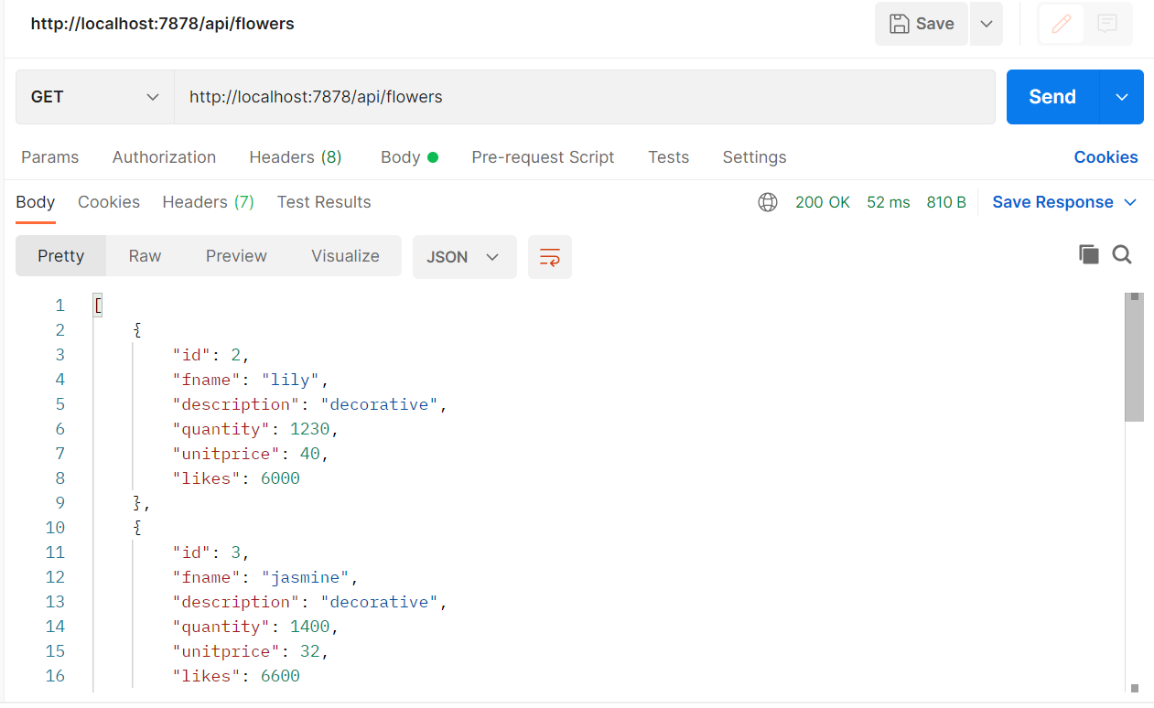

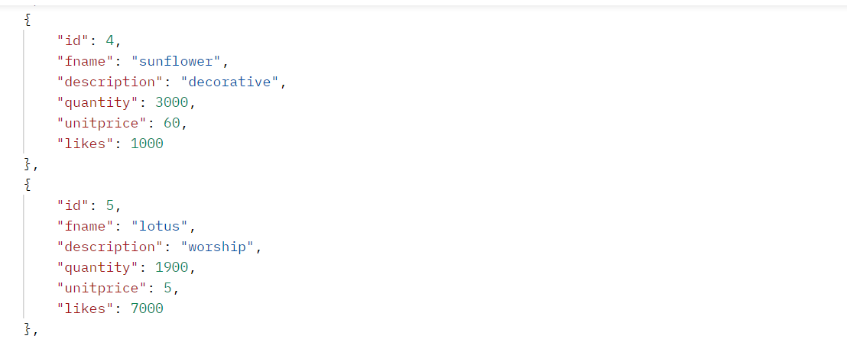

GETBYID

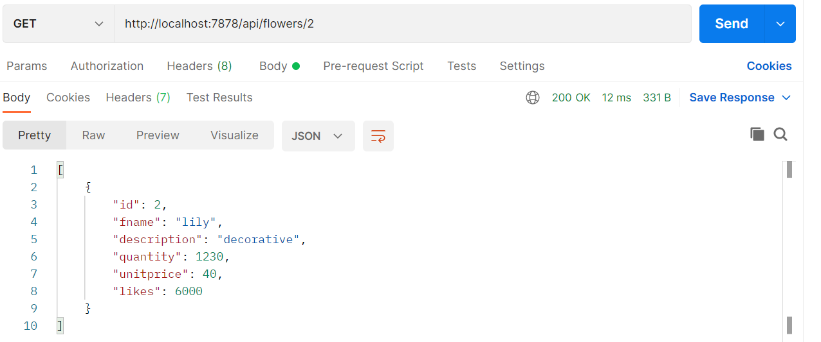

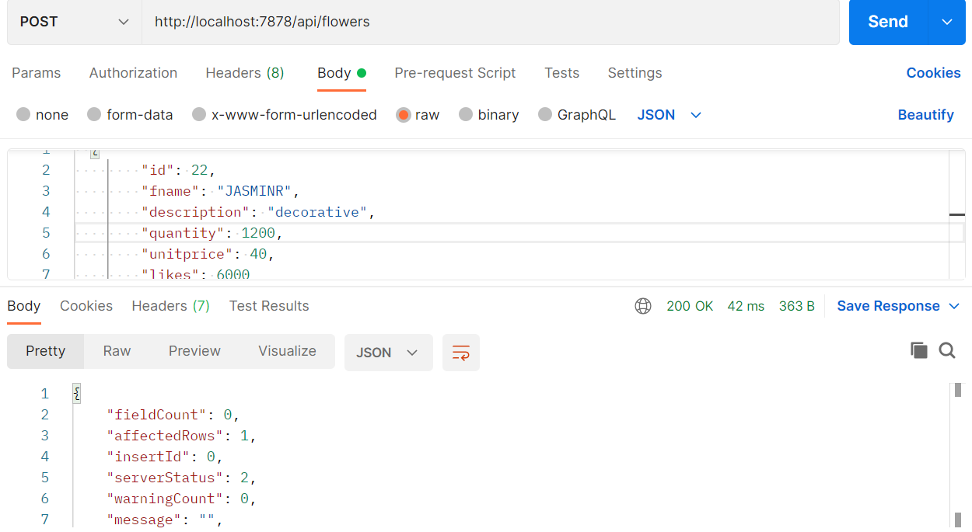

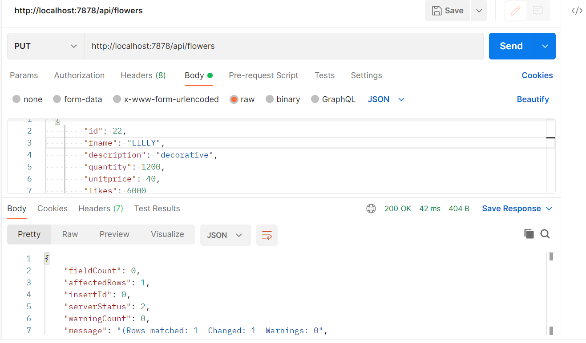

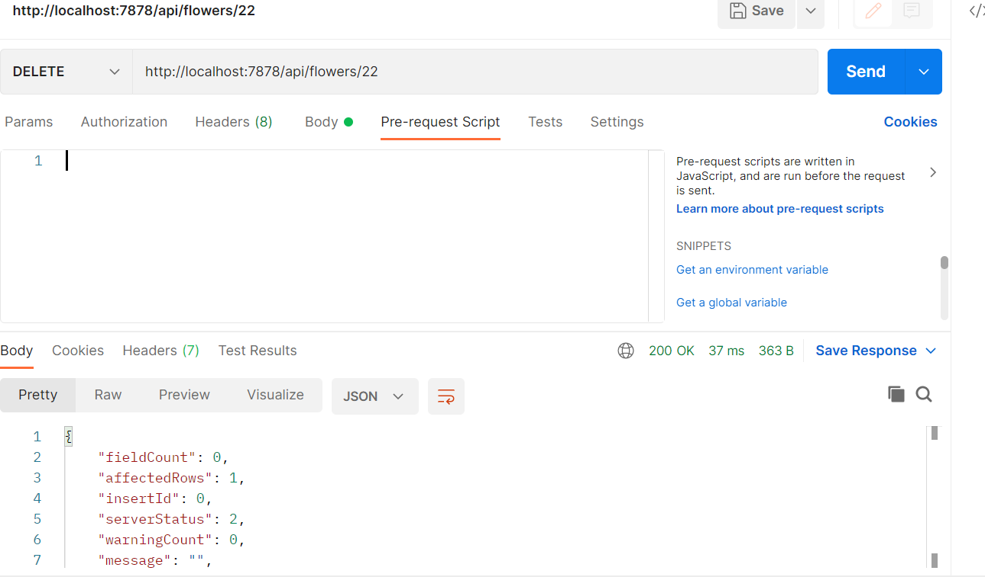

2.CUSTOMERS

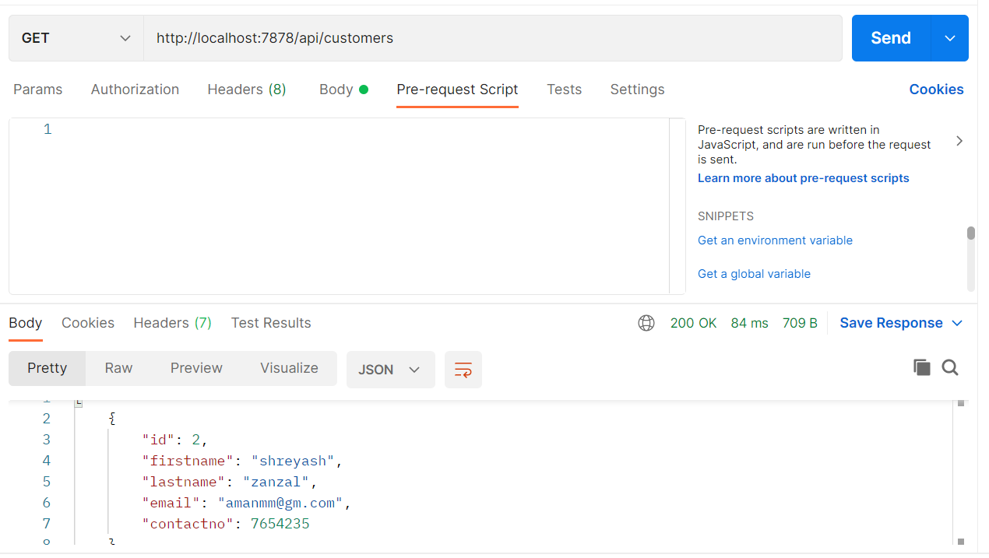

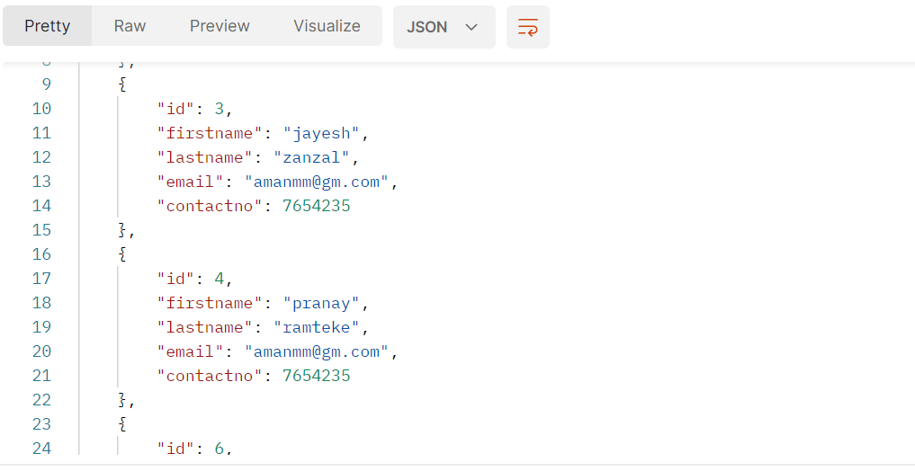

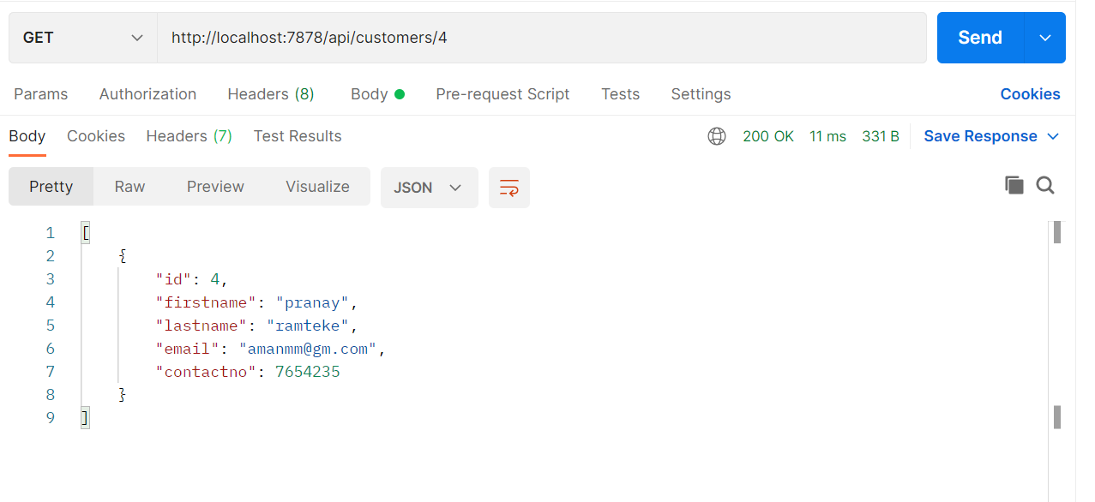

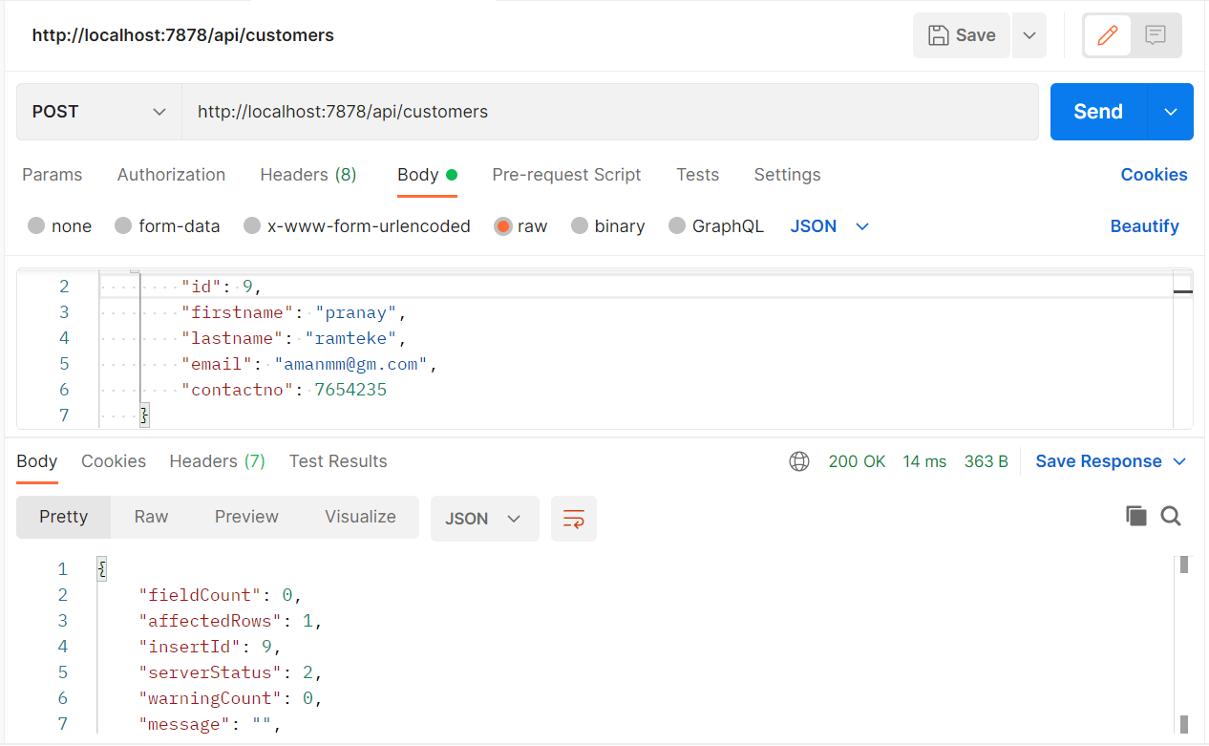

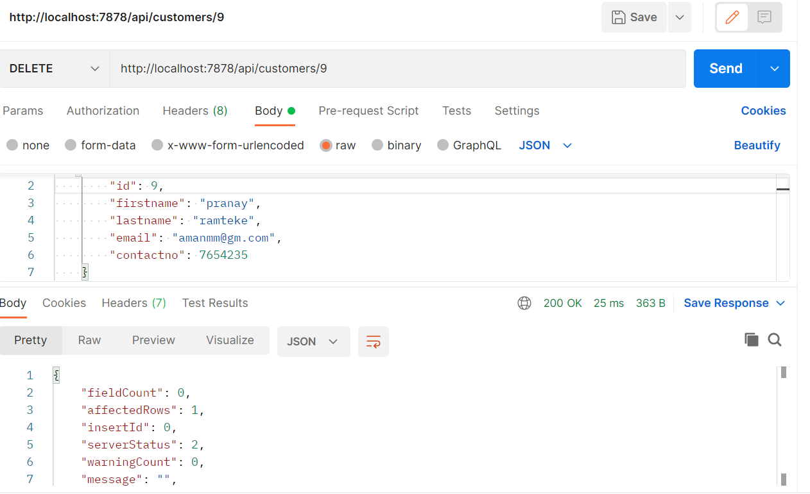

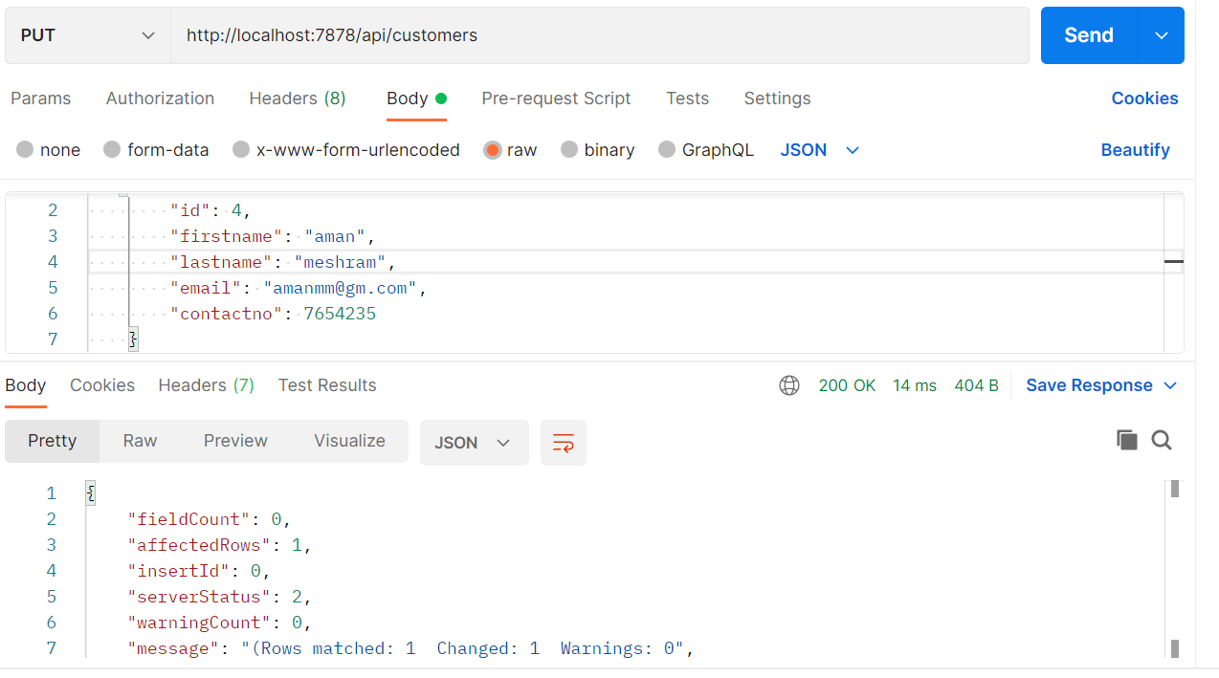

3.ORDERS

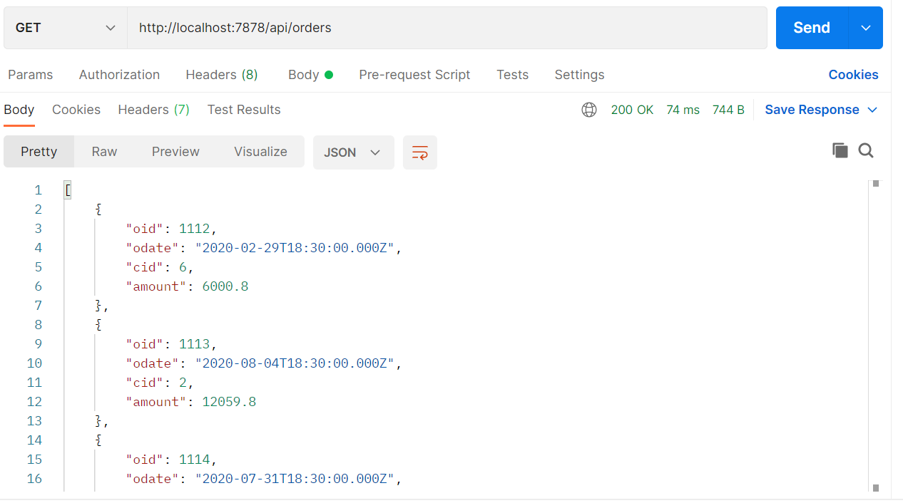

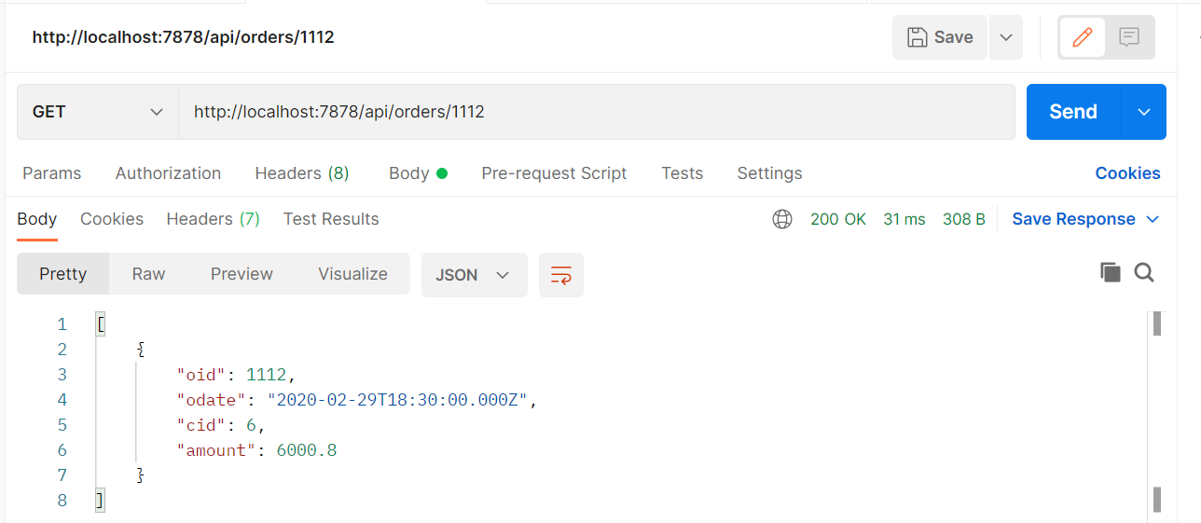

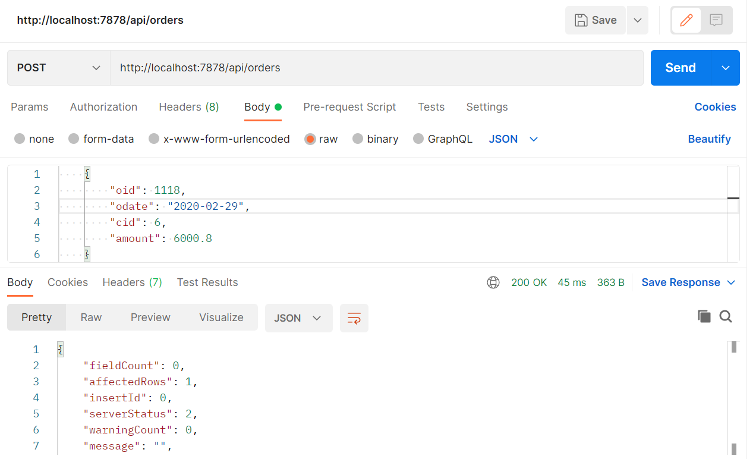

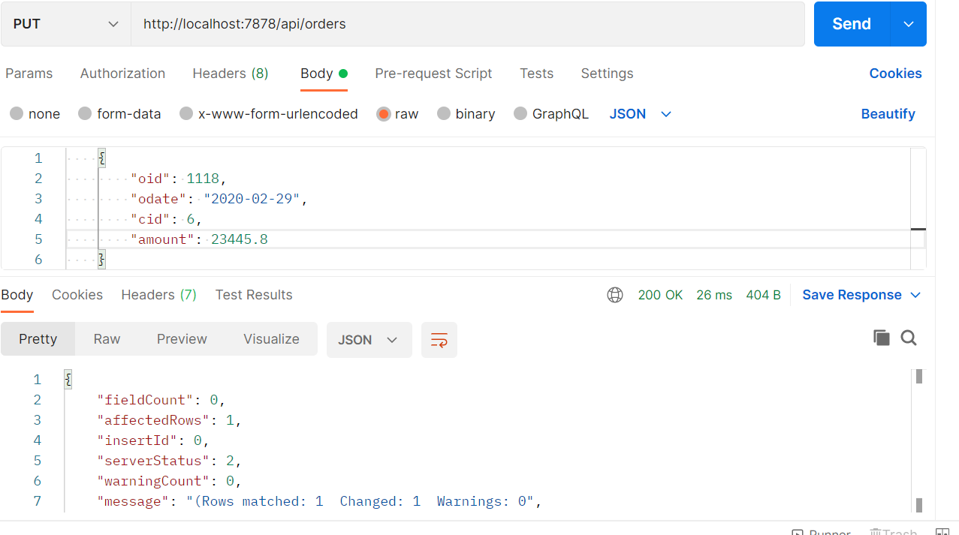

4.ordersitem

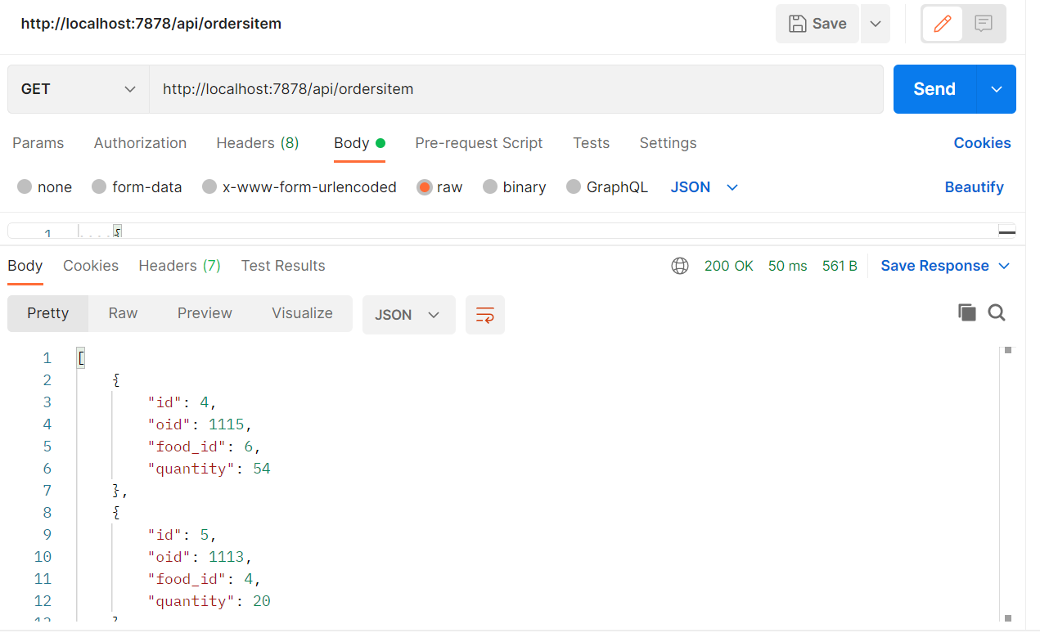

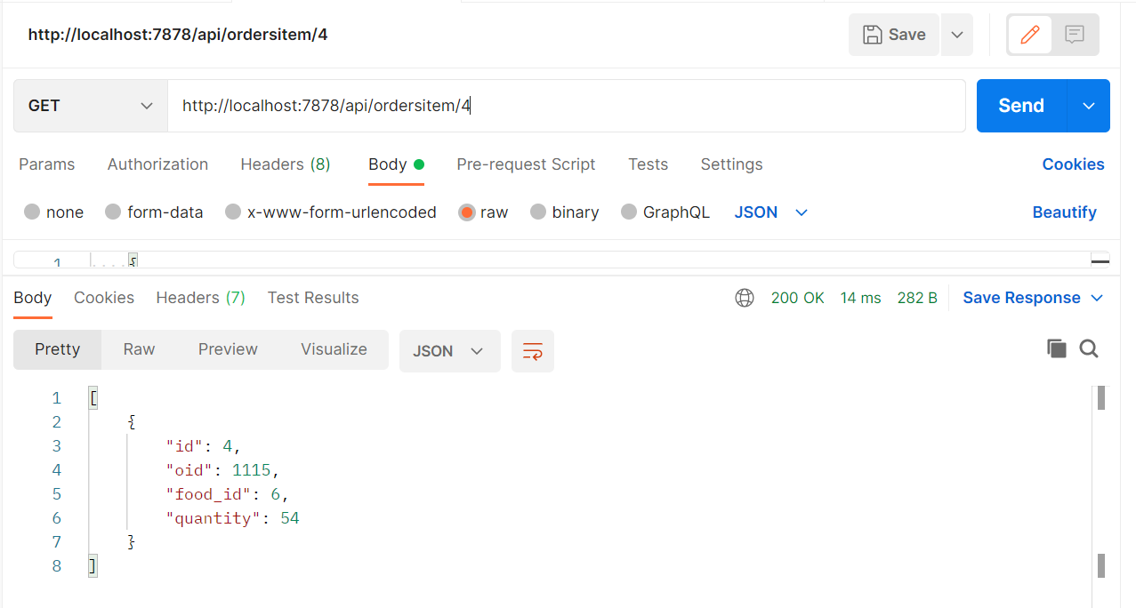

DATABASE TABLES:

